HRH Visit to Livability Treetops

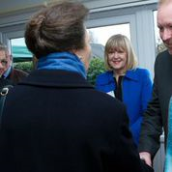

On the 31 March Wendy and I attended the HRH Livability Treetops Visit at Victoria Gardens
Highwoods in Colchester and were in the presence of their Patron, Her Royal Highness The
Princess Royal. Livability is the UK’s largest Christian disability charity. The purpose of this
Event was to see how the Home Design Appeal provides high quality homes for disabled
people that enhance their potential by enabling them to live their lives to the full. The visit was
very interesting and as well as meeting the Princess Royal we were given a tour of the facilities
at Treetops which is a high dependency unit for 21 very disabled residents. Each resident
has a self-contained flat enabling them to remain as independent as possible as well as allowing
them to be part of a larger community. .Livability need to upgrade the communal bathroom to
include a new bath and to make it into a sensory facility. They will be submitting an application
for part funding of this upgraded facility.

Stephanie Grant
Administrator

